**EXECUTIVE SUMMARY**

To begin with, the traditional approach will not encourage people’s involvement/participation in the way the project is being presented, they will lose focus eventually no matter how serious or crucial the topic of discussion is.

In fact, the average attention span among people who listen to speeches is estimated to be somewhere in the 5–10 minute span, and often towards the lower end of this.

(Rehn, A.) This traditional approach also requires the presenter to be really involved in the topic of discussion as the body languages throughout the presentation will portray how much the presenter wants the audience to be involved in the subject as well.

When it comes to multimedia, navigational, and participatory features give greater adaptability and control to the learners and users. With interactive media, clients become members in an energizing encounter including the tactile modalities of sight, sound, and contact, all of which normally encourage learning.

**Increased Motivation:** Instant feedback and individual power over the substance given by an interactive multimedia system has demonstrated to be exceptionally inspiring to students.

**Reduction of learning time:** There has been some research which shows that training in the prospect of interactive multimedia can reduce the time of training up to 60% over traditional classroom methods. This factor can be ascribed to the quick association and consistent criticism which gives incredible fortification of ideas and substance. Besides, self-managed guidance which permits students to control the movement and substance of their adapting i.e., more troublesome ideas can be rehashed or recognizable substance can be skipped.

**Flexibility:** The flexibility originates from the capacity to explore, by utilizing a keyboard, mouse, or a touch screen, through an interactive program and to pick what and how much data we need and when we need it. (C., K. (n.d.))

To start with, it is important to give out a message to the audience regarding to the topic in an animation format. For instance, we could come up with an animation that will give the audience a message regarding the covid-19 topic by including two or more individuals where some are wearing masks where others aren’t. Some of the individuals has the covid infection as well. The animation could show how a person could actually save themselves and others around them by just wearing a mask and socially distancing themselves. Afterwards, the audience would be provided with choices on how to interact with the situation at hand by controlling one character and deciding on certain actions which would result in either saving themselves from the virus or jeopardizing everyone around them. Advertising the animation that is made to give out the message so that it reaches out to more people. Trendy individuals having huge influences on the people would be a great factor that pique their interest and would actually try to involve themselves on the topic.

**PROJECT TITLE AND OBJECTIVES**

**Title: Covid Tracking and the cruciality of awareness**

**Objectives:**

- Making sure that the audience understand the message being given by the animation

-Accessing the audience’s understanding by making them interact with the application.

-Based on the actions that the audience made, there will be additional messages that are either going to commend them or reeducate them on the action they should’ve taken to avoid the consequences that followed.

**CHARACTERISTICS OF USERS**

The target audience is basically every individual of different sex and different age range but the highlight is on the people having pre-medical conditions, elderly people, and disabled people. Research shows that people under the categories stated above have higher chance of death rate than other people. As of May 13, 2020, the statistics show that elderly people falling under the age range of 75 and above have 48.7% death rate. The application will involve animations that are colorful, vibrant, and eye-catching for the general public. The follow-up interactive control will also follow the same color scheme setting so that the general public interacting with the interface would feel like they are a part of the experience and would actually absorb the information given by the application within minimal time setting. The more people the application approaches, those people can then be able to inform their associates about how attractive the application is and in turn bringing in more people. Therefore, with more people being reached out, the purpose of the application itself will be attained by the majority of the society and its aim will come to fruition as a result.

**CONTENT SPECIFICATIONS**

Audio

Sound can improve our application’s composition and subsequent media stages. It is a sight and sound application. It is a multimedia element that utilizes exchange, recorded portrayal, music, and audio effects. These are known as the sound components. At the point when utilized with some restraint, adding multimedia such as sound to the presentation can be an incredible method to catch and center the guest's attention, to convey data to guests, and to help strengthen the guest's appreciation of the data introduced.

Animation

Animated components are customary multimedia applications. Animation is basically defined as a progression of pictures set up to give the perception of movement. In interactive media, 2D and 3D computerized animation is utilized. Movement, as opposed to simply seeing an actual picture, is particularly helpful for showing ideas that include development. Animation is utilized to include visual intrigue or highlighting significant information or links. It can show how things work or present data in engaging manners. Animation can likewise incorporate interactive impacts permitting visitors to draw in with the liveliness action utilizing their mouse and keyboard. Animation is a dynamic and media-rich substance that stays inside one compartment on a page – an exceptionally incredible type of correspondence.

Delivery Platform

To ensure that the application properly reaches to as many people as possible, we can use blog as a multimedia platform. Blogs would basically allow us to effectively communicate with the audiences through what we create. A blog is a site with journal-style passages on points intended to illuminate and welcome remarks. Frequent visits can result in people creating other blogs talking about the blog we created and therefore resulting in more people reaching out to us. We can use social media platforms like QQ as well so that people can watch and even share our application making it pop up in people’s news feed.

How audio and animation will be used

Sound expands the visual components in the application to present the story behind well. It is also important that certain visual elements match with the audio being added. For instance, there will be some sort of a trombone-like sound effect when the person without wearing any mask come into contact with an infected individual etc. Natural outdoor sounds will be added to perfectly fit the setting as well as other sound effects specifically for certain interactions caused by the user.

The animation will involve several characters and one of them will denote how certain precautions are to be taken during the pandemic like wearing a mask, using hand sanitizers etc.

Text

As a multimedia choice, text can easily be ignored, however, it is yet the most key component and best approach to impart in multimedia. Text is utilized as features, captions, and trademarks. Its purpose is to communicate explicit data or fortify data in other media. It includes the utilization of text types, sizes, shadings, and background color. Text can make the proposed message you need to pass on through sight and sound more reasonable, it very well may be utilized as an option on the off chance that an advanced picture isn't accessible in a guest's program, and other media or related data can be accessed to by tapping on text links.

Images

Designs are a significant piece of media because people are outwardly arranged. There is no development in these kinds of pictures. Still/static pictures commonly go with text to outline the point or thoughts the content makes. Photographs in a multimedia application go past utilizing them similarly as enrichment. In a sight and sound setting illustrations may comprise of slide shows or displays that a site or online media guest can see. They may have interactivity that drives the watcher to another component, for example, sound or video. Illustrations show up in numerous mixed media applications giving correspondence through alluring visual effects.

**FUNCTIONAL SPECIFICATIONS**

Interactivity

In order to ensure that the audience understand the message we’re going to allow them to interact with the application at hand by using the knowledge acquired from the initial animation being shown. As we’ve mentioned in Task 4, there will be certain actions that the audience can do by using the keyboard and the mouse. The actions include approaching individuals wearing masks, individuals not wearing masks, individuals who are close to each other as well as having the option to wear a mask and leave the scenery. The interaction can result in the audience either grasping the main points provided in the animation and doing the proper action accordingly or just subsequently do actions that results in bad consequences like going into the crowded area without wearing any mask. However, no matter what kind of action the audience does, they will attain the points before exiting the application as even after the bad consequences are portrayed there will be pop-up messages notifying the audience that whatever the action, they did was wrong and also explaining why. Then, the appropriate action that should have been taken will be provided so that they know what to do in a real life situation similar to the scenario provided in the application.

Communication

The means of communication is also important especially these days as physical interactions are limited under the CMCO. So, the aftermath of the audience’s interaction will basically be how they can enforce protection for themselves and also for the people that they care about. It is obvious that we cannot provide every information there is when it comes to Covid-19 and people’s safety. As a result, people would want to look for other means to contact us to continue discuss on the matter. Therefore, we will be giving the audience an option to enter their email addresses so that we can update them on their overall health and answer to their related concerns as well. We can also give them reminders on how to follow the SOP and the consequences that could result if not attentively obliged.

**STORYBOARDS**

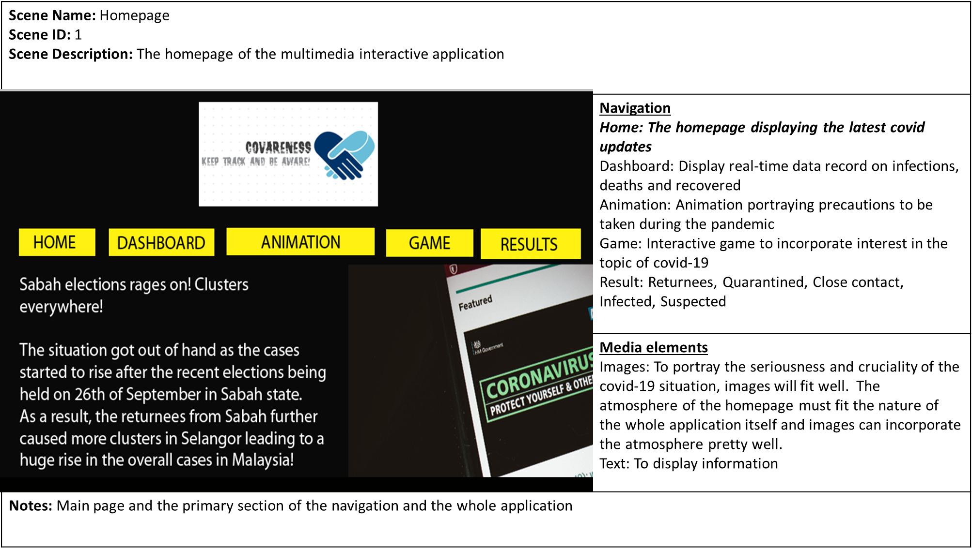

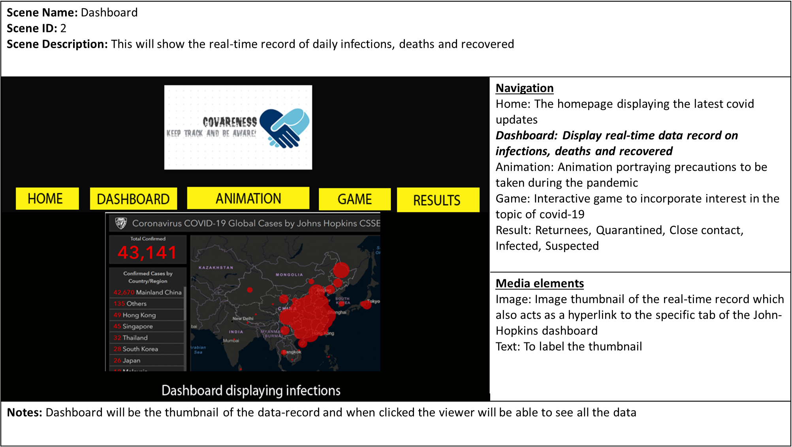

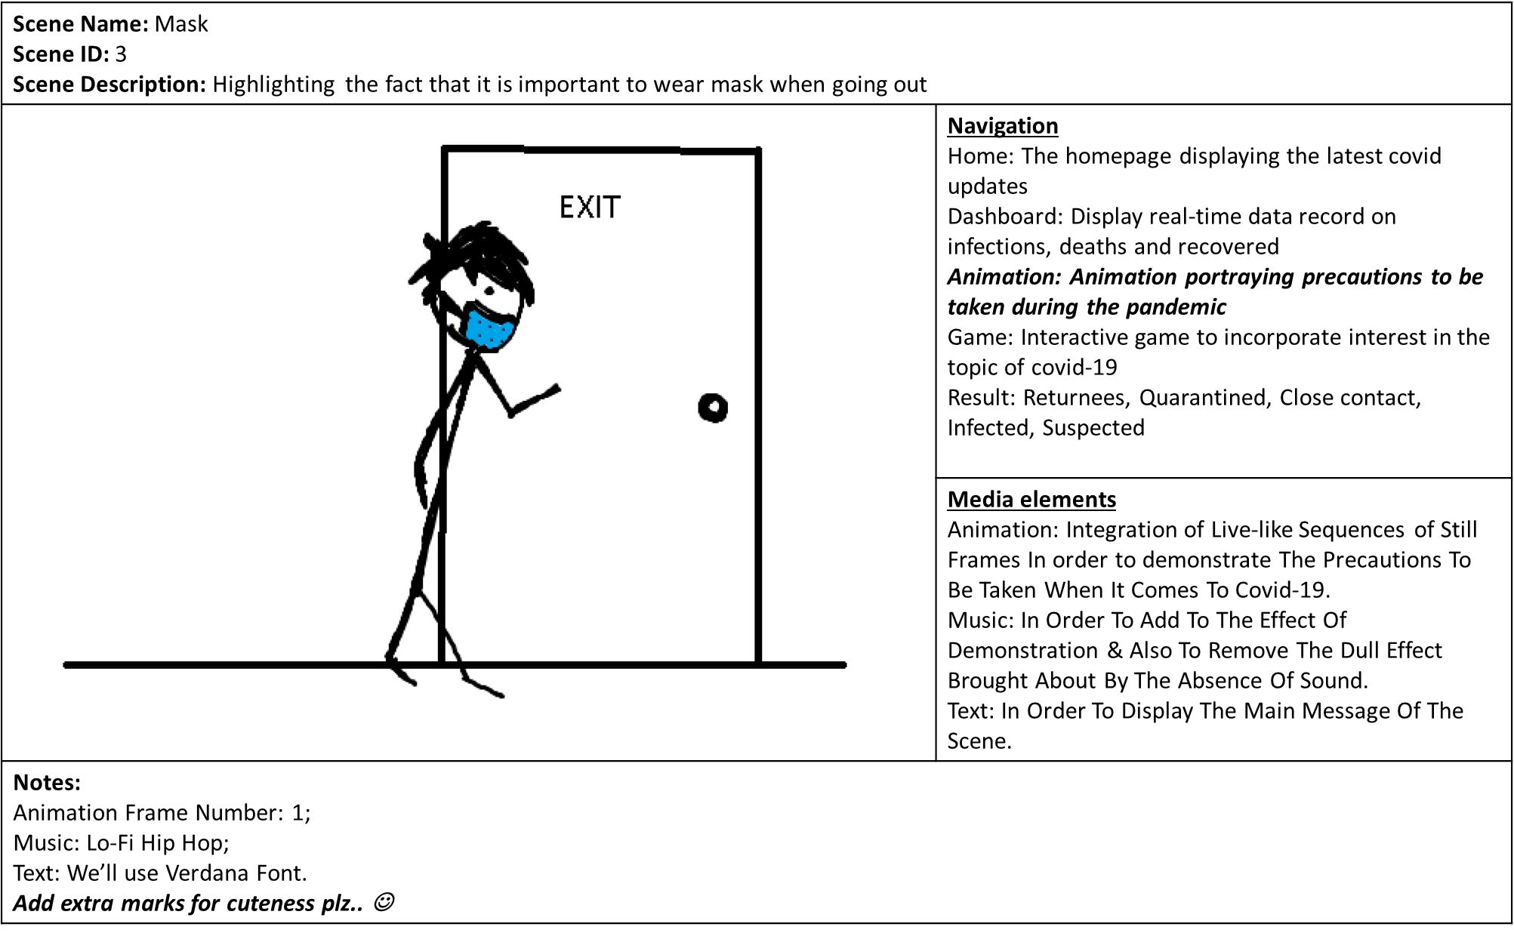

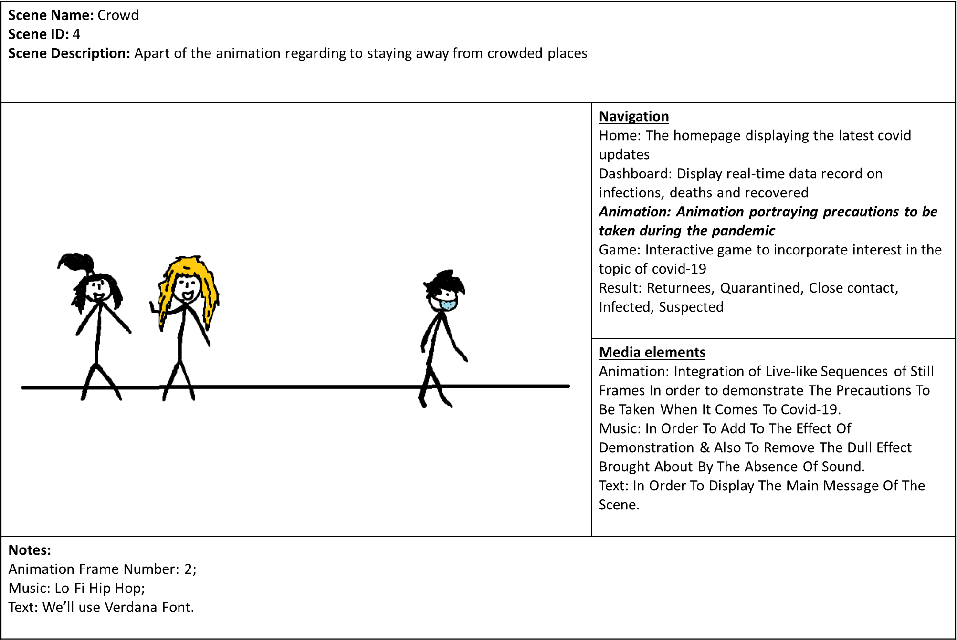

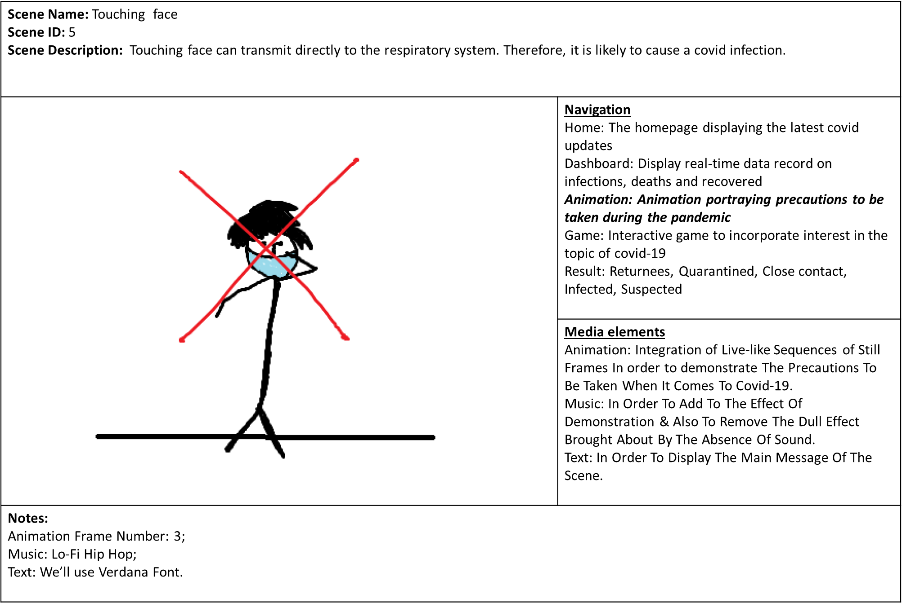

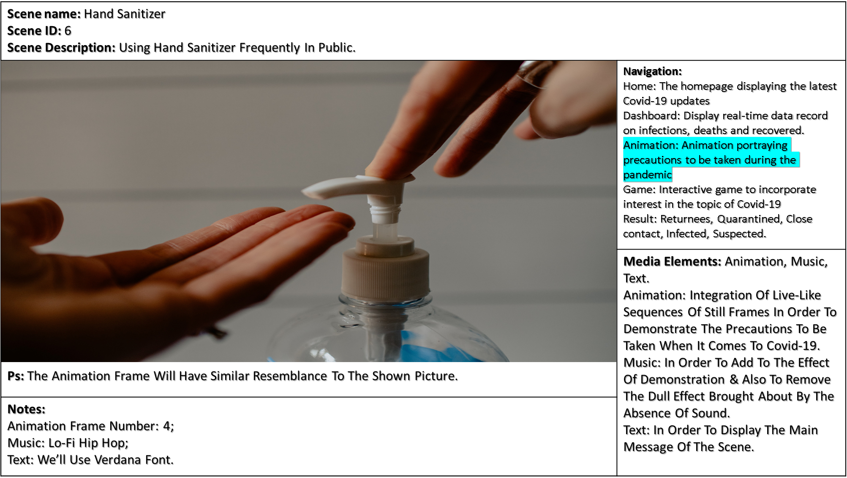

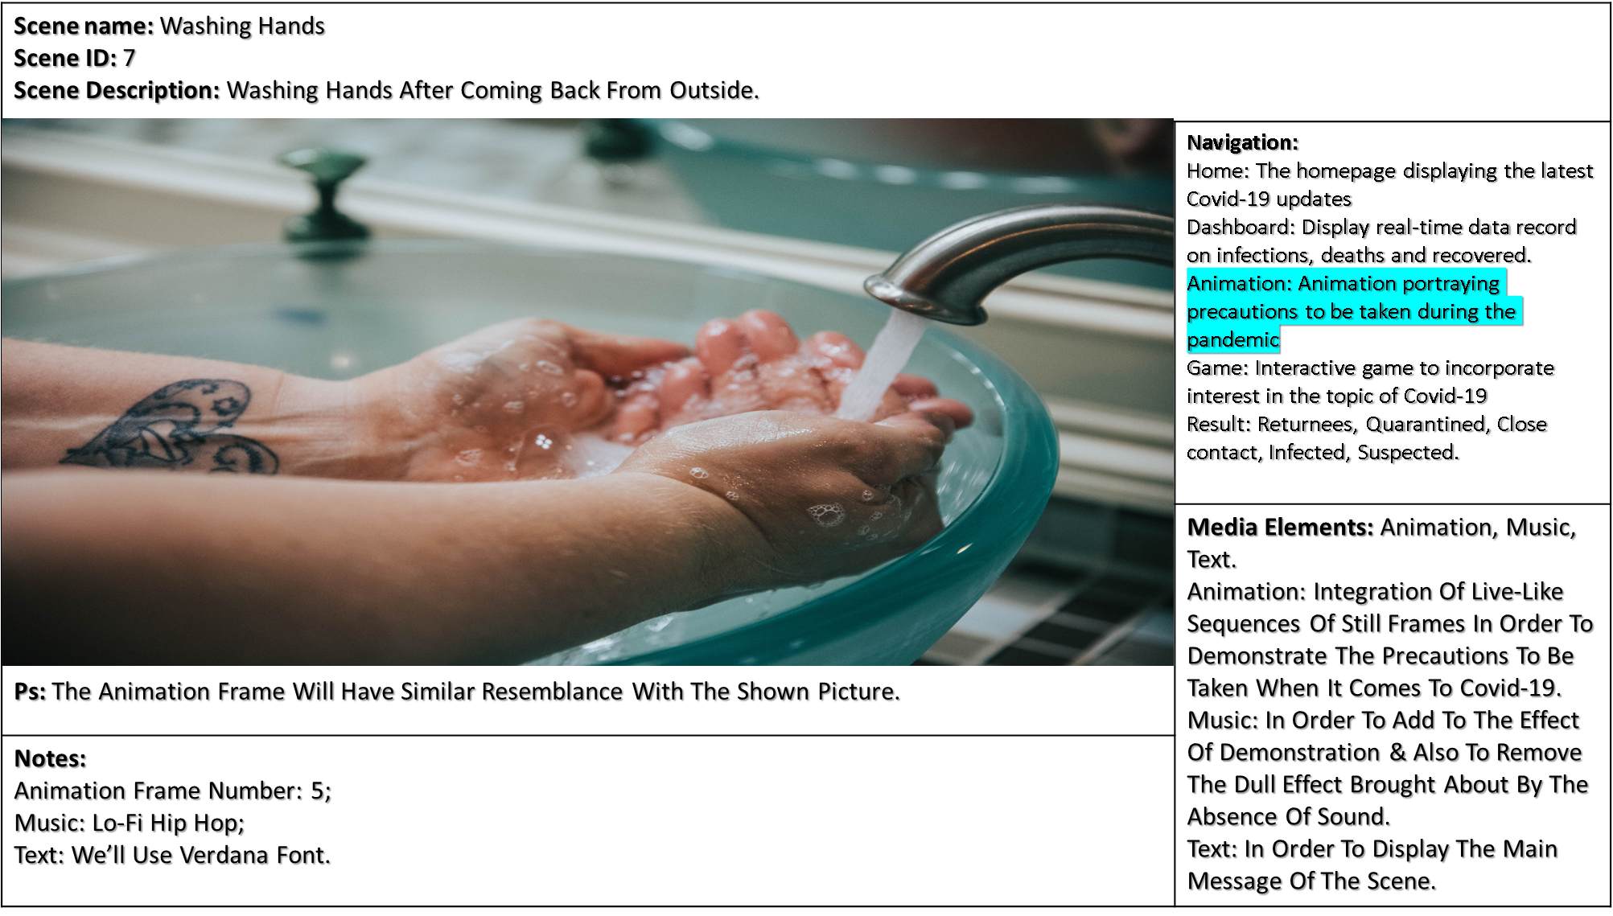

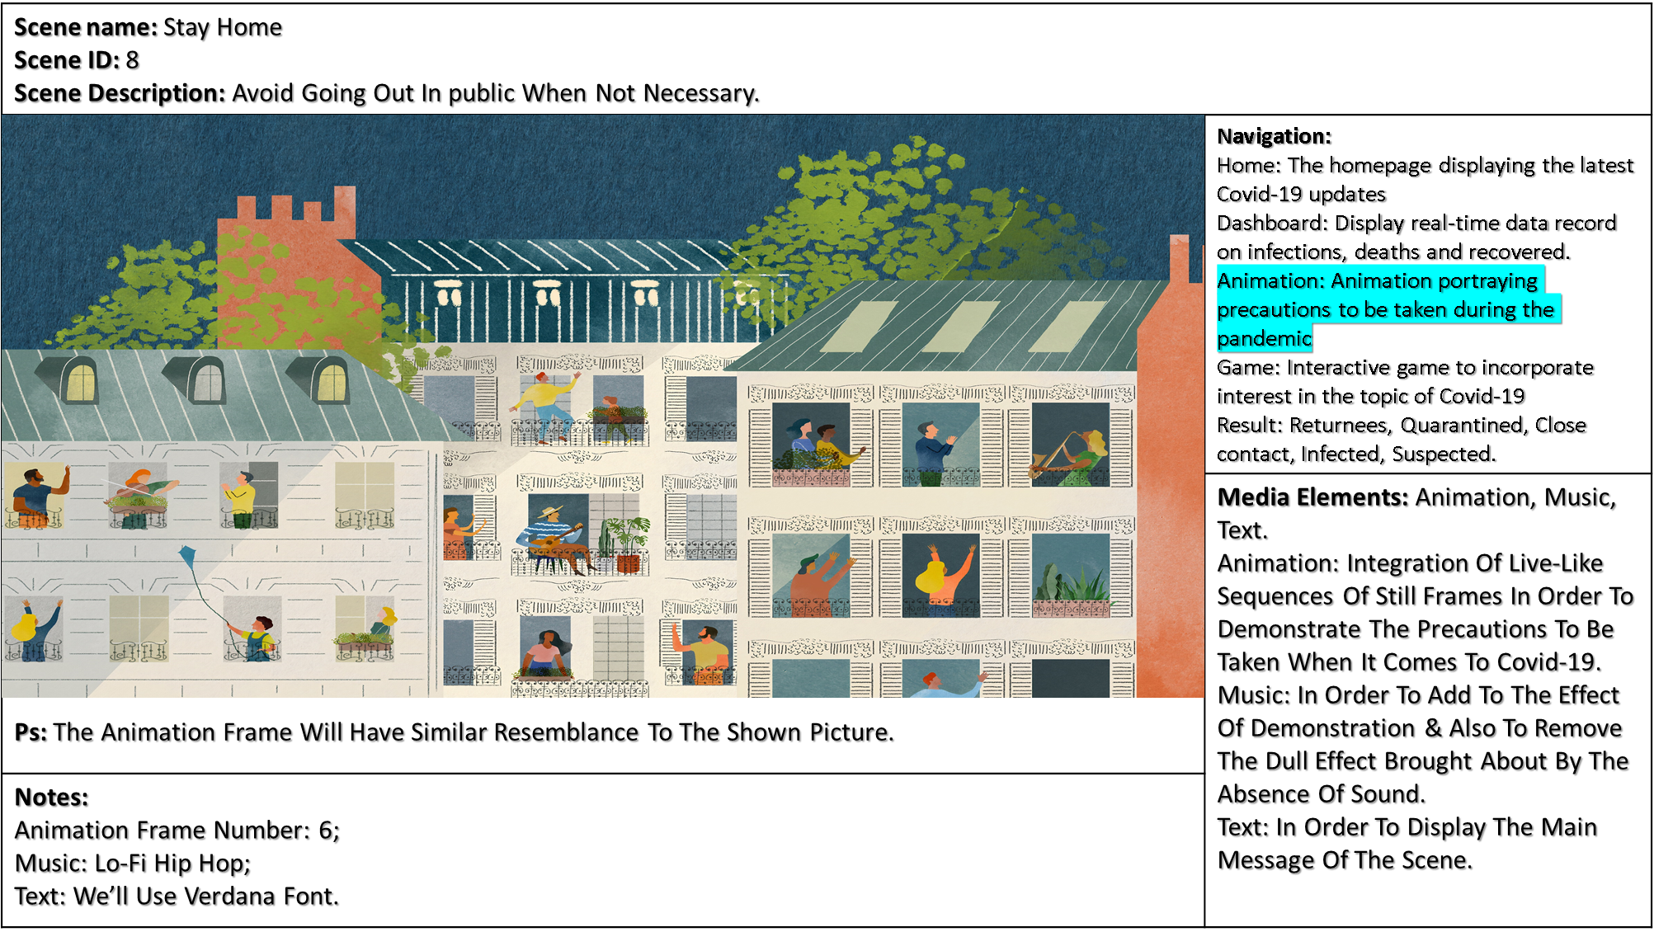

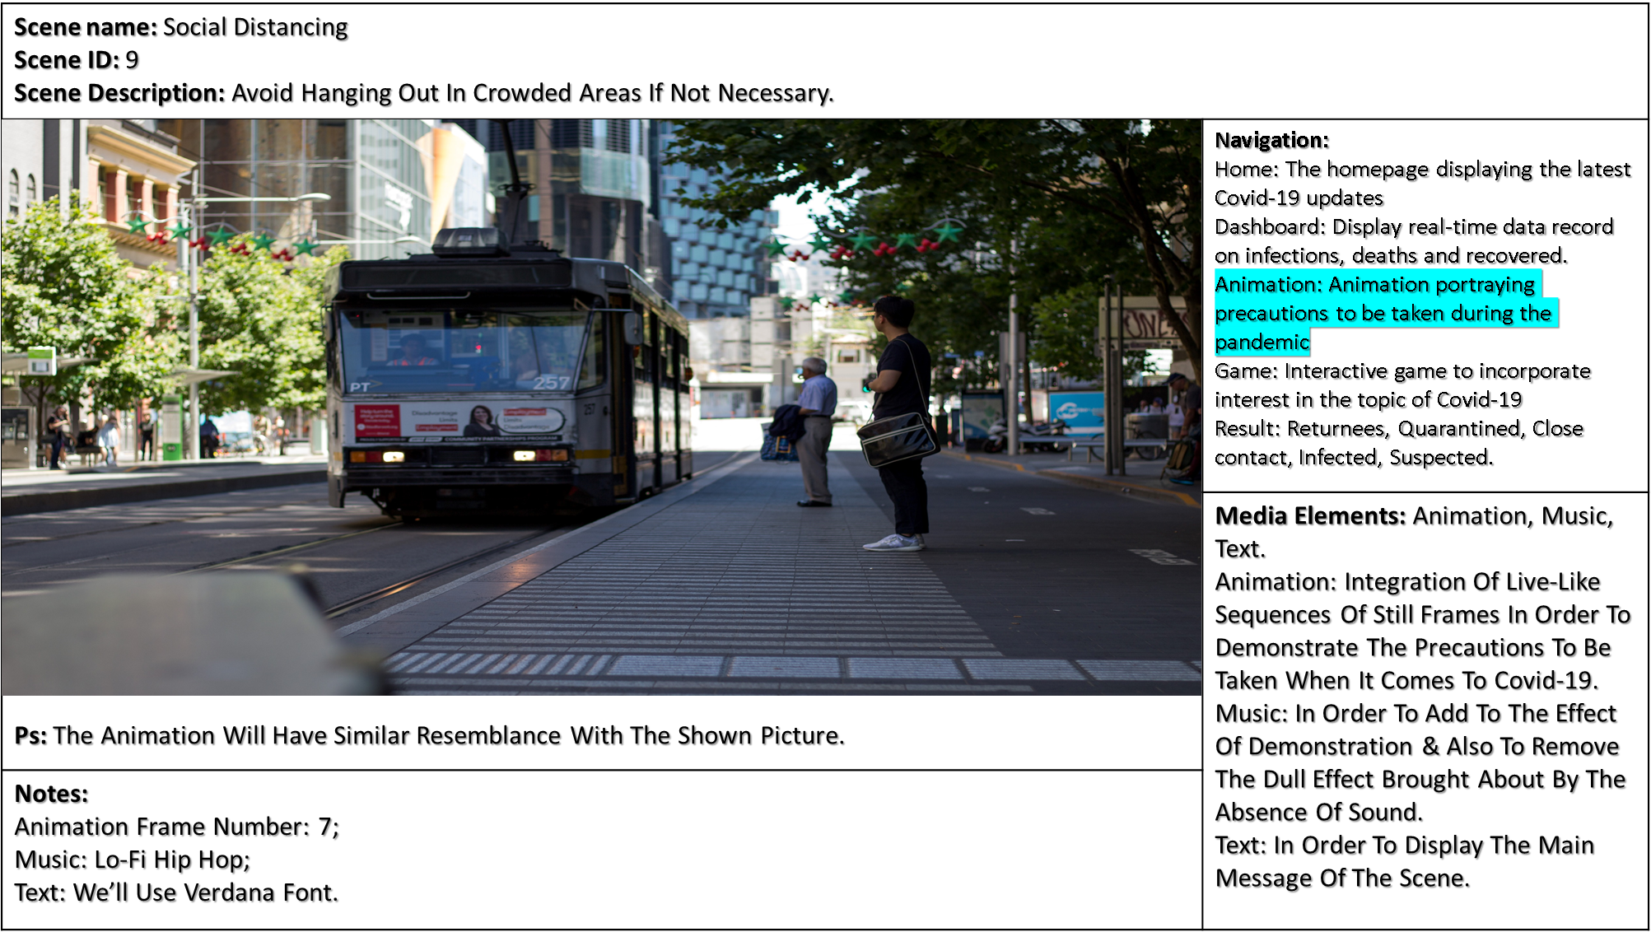

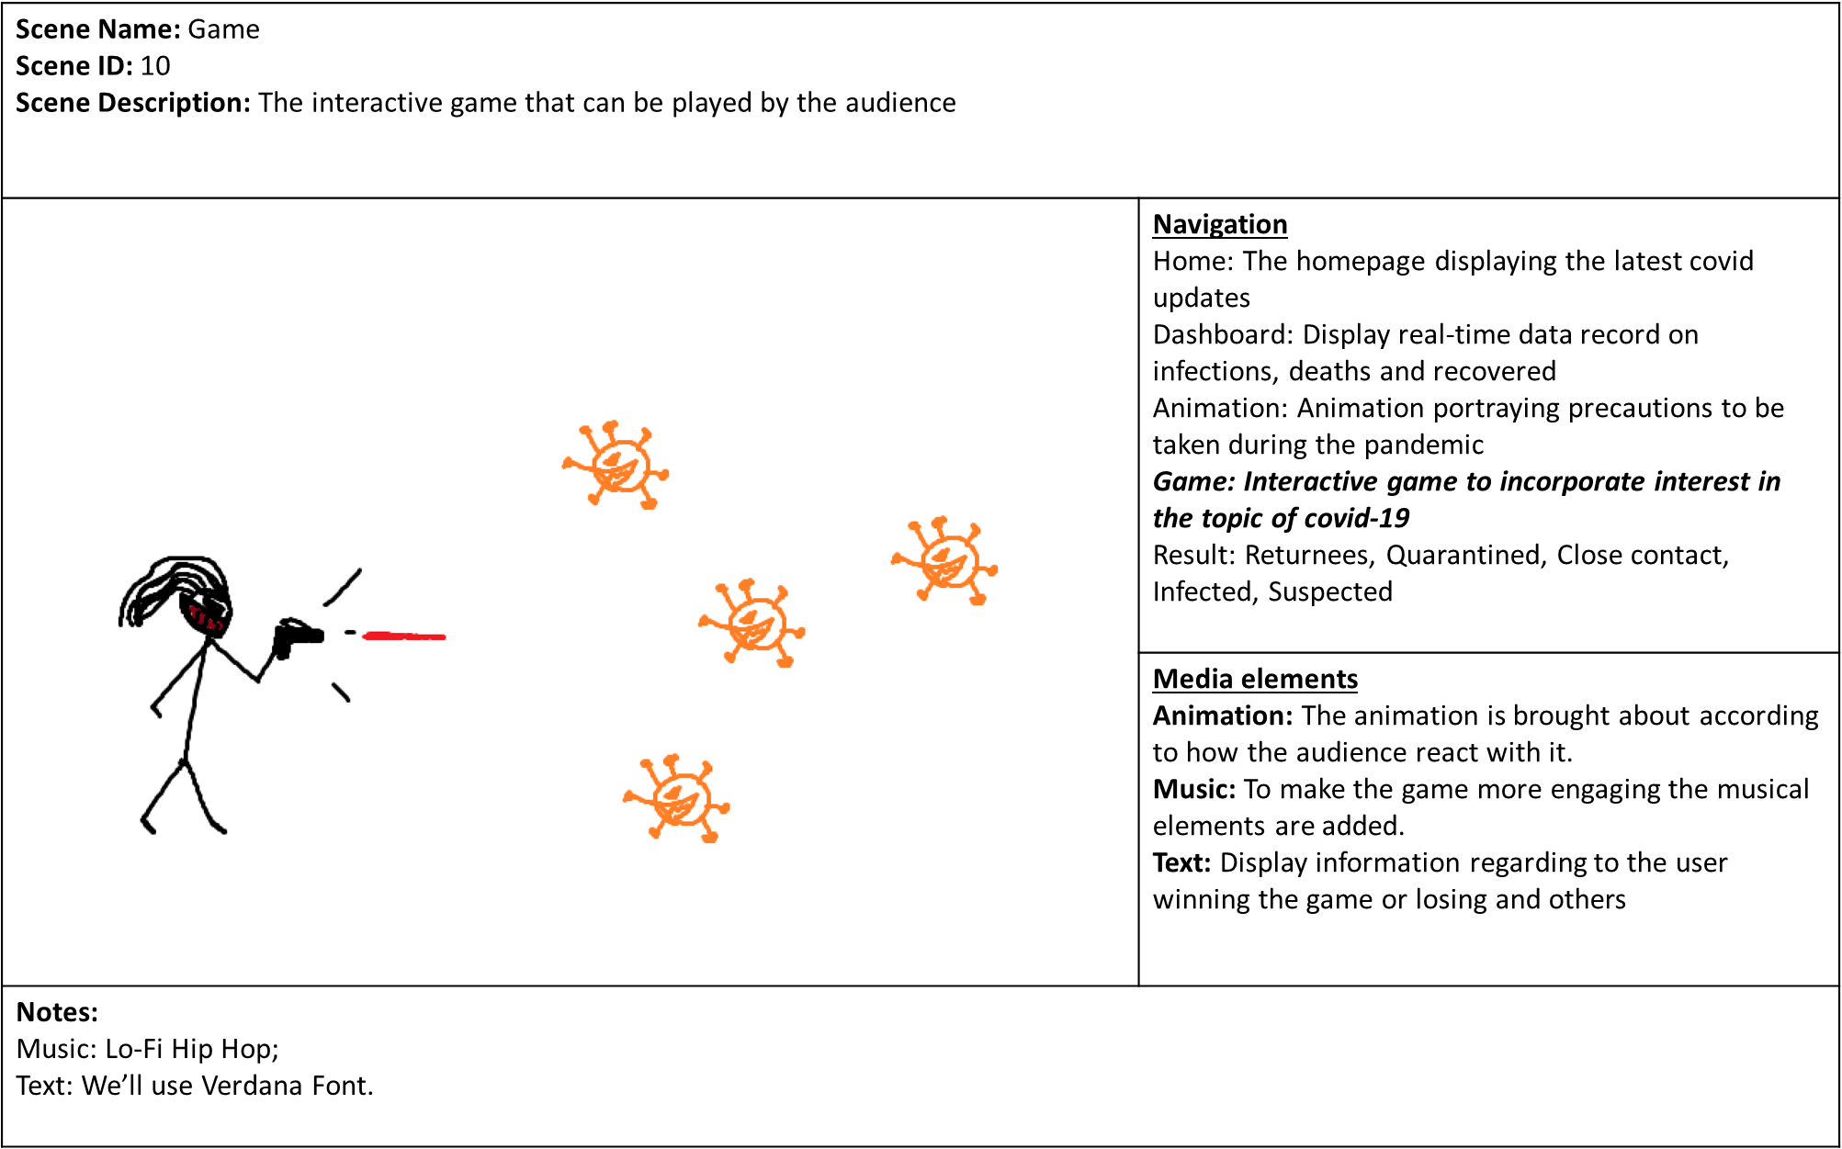

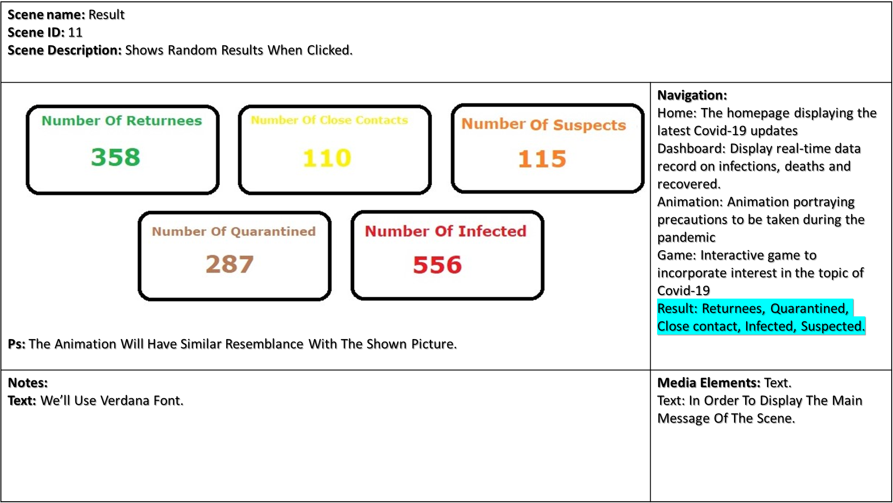

**PROJECT TIMELINE**

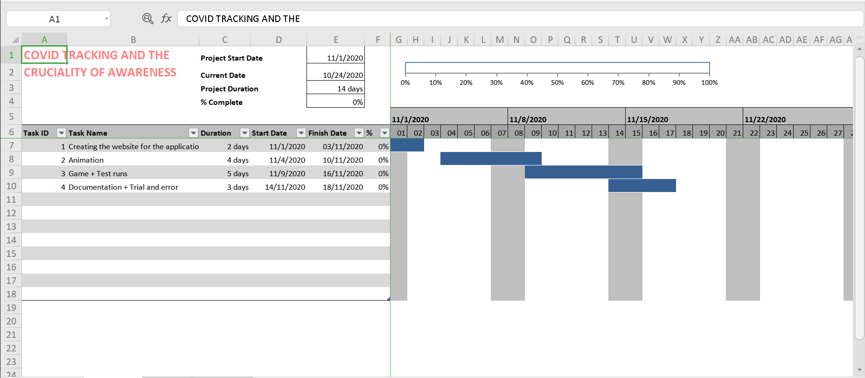

Note: Exact details can be referred to in the Excel file

***References***

Rehn, A. (2016, April 11). The 20-Minute Rule for Great Public Speaking - On Attention Spans and Keeping Focus. Retrieved October 17, 2020, from <https://medium.com/the-art-of-keynoting/the-20-minute-rule-for-great-public-speaking-on-attention-spans-and-keeping-focus-7370cf06b636>

C., K. (n.d.). Retrieved October 23, 2020, from https://ascilite.org/archived-journals/aset/confs/iims/1994/km/khoo.html

Unsplash. (n.d.). Hand Sanitizer Pictures: Download Free Images on Unsplash. Retrieved October 23, 2020, from https://unsplash.com/s/photos/hand-sanitizer

Unsplash. (n.d.). Washing Hands Pictures: Download Free Images on Unsplash. Retrieved October 23, 2020, from <https://unsplash.com/s/photos/washing-hands>

Unsplash. (n.d.). Stay Home Pictures: Download Free Images on Unsplash. Retrieved October 23, 2020, from https://unsplash.com/s/photos/stay-home

Unsplash. (n.d.). Social Distancing Pictures: Download Free Images on Unsplash. Retrieved October 23, 2020, from https://unsplash.com/s/photos/social-distancing

Unsplash. (n.d.). 500+ Results Pictures [HQ]: Download Free Images on Unsplash. Retrieved October 23, 2020, from <https://unsplash.com/s/photos/results>